**Dashboard - Graphs and Plots**

**User Engagement and Retention**

* **Distribution of Users by Average Screen Time**

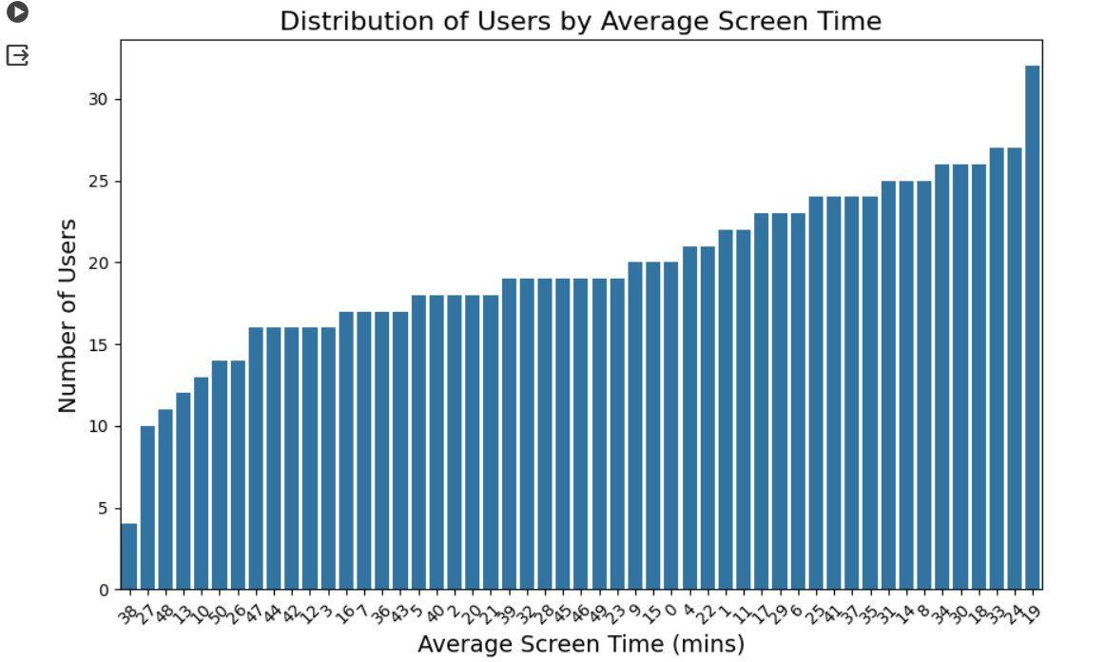

* **Average Screen Time for installed vs. uninstalled users**

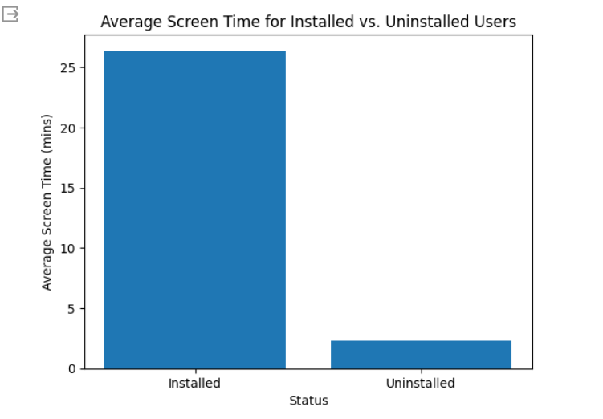

**Revenue Potential**

* **Distribution of Users by Average Spent on App**

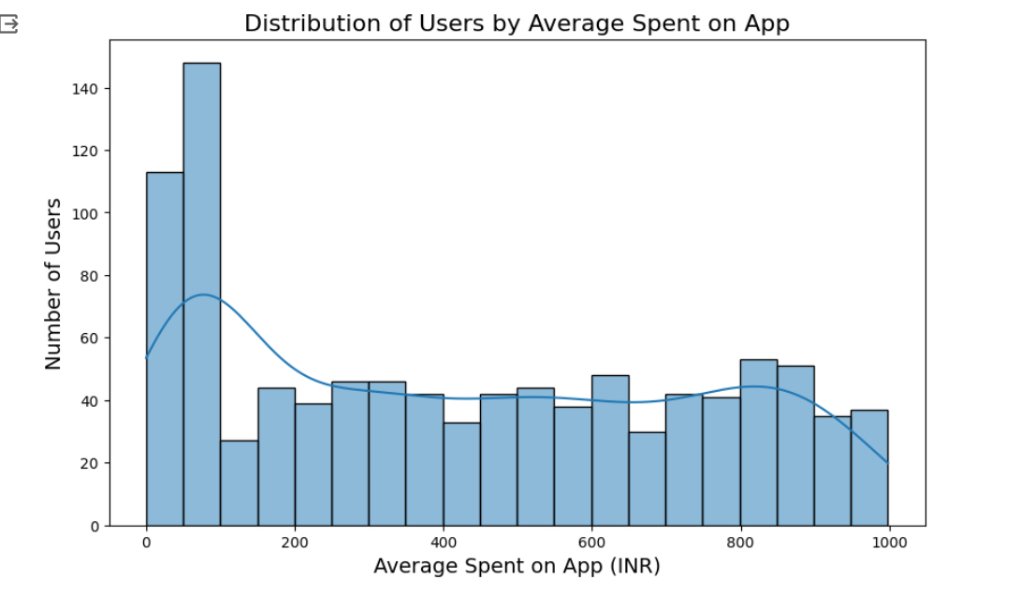

* **Correlation between Average Screen Time and Average Spent**

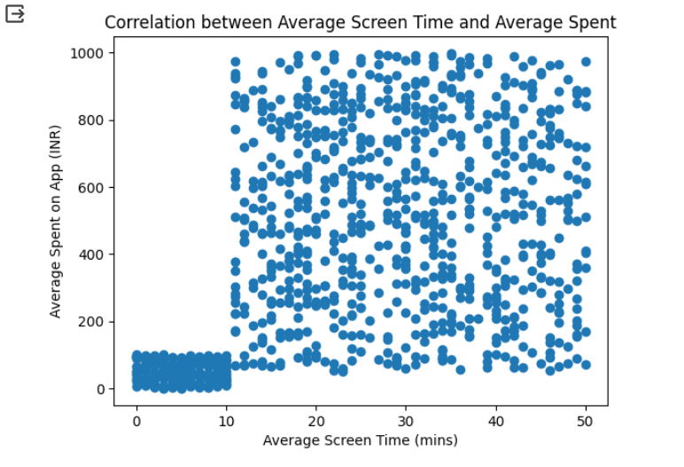

* **Last Visited Minutes vs Average Spent on the App**

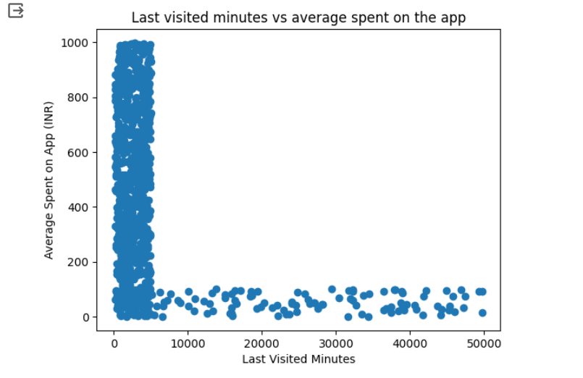

* **Ratings vs Average Spent on App (INR)**

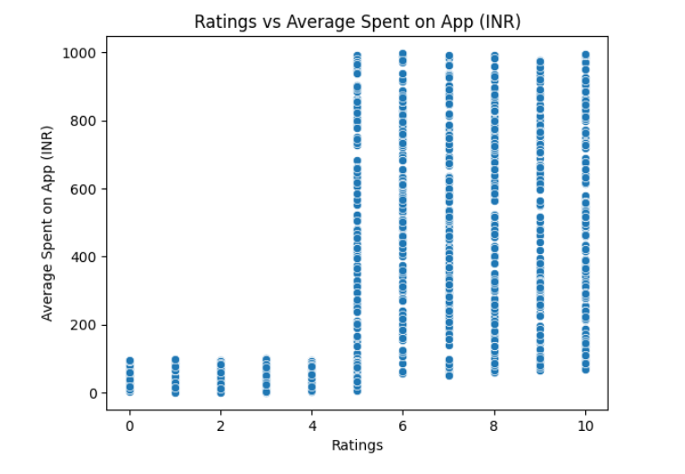

* **Status vs Average Spent on App (INR)**

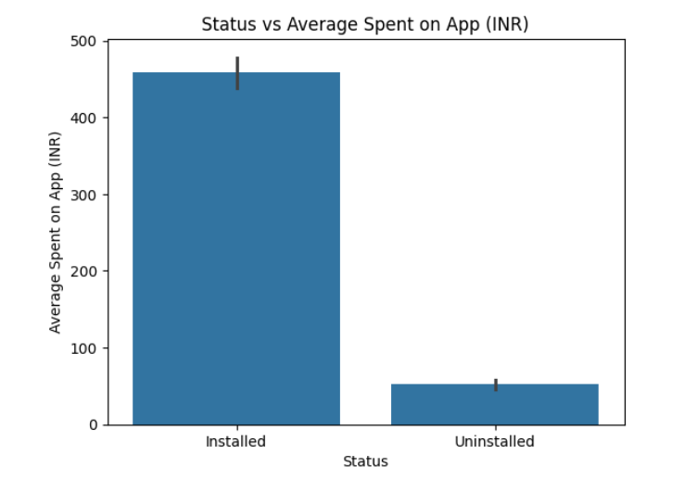

* **Spending patterns of high-value users**

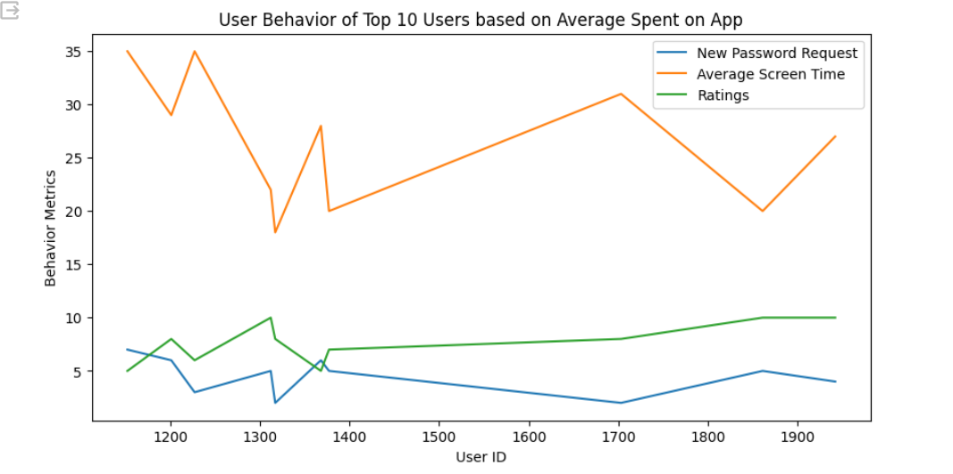

**User Satisfaction**

* **Distribution of Users by Ratings**

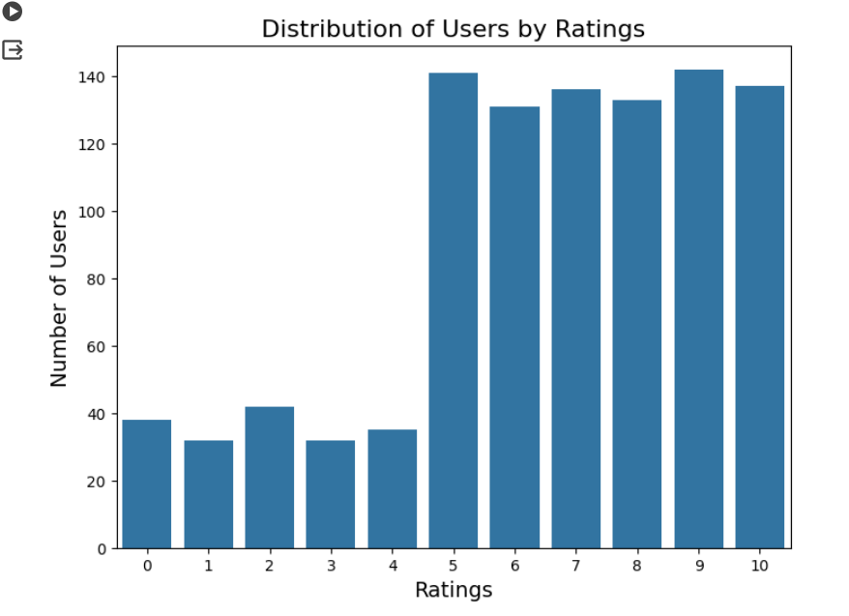

* **Relation between User Review on Ratings**

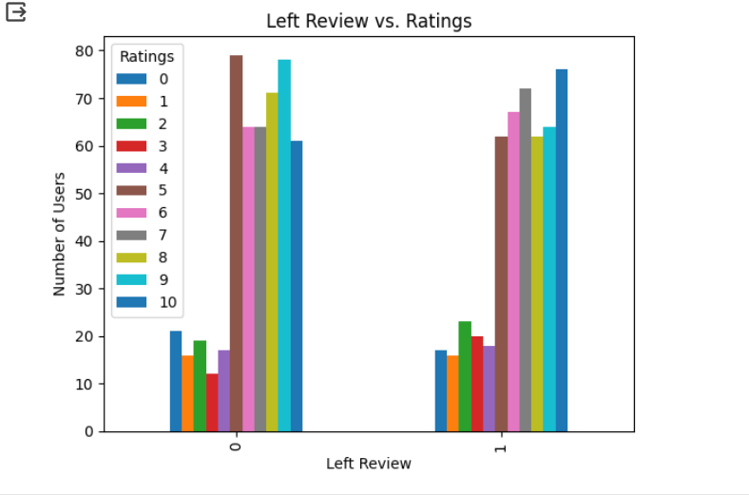

**User Experience Optimization**

* **Distribution of Users by New Password Request**

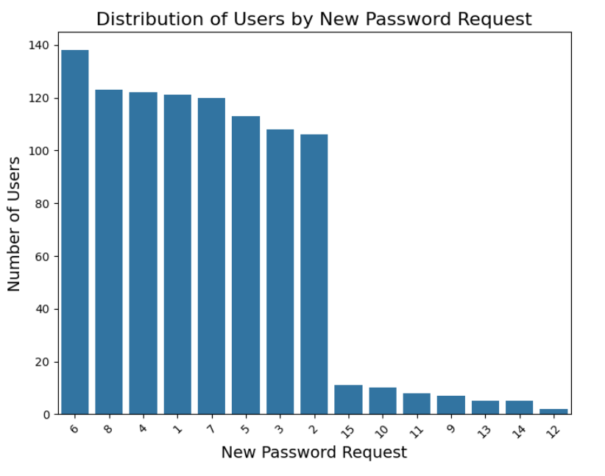

* **New Password Requests v/s Ratings**

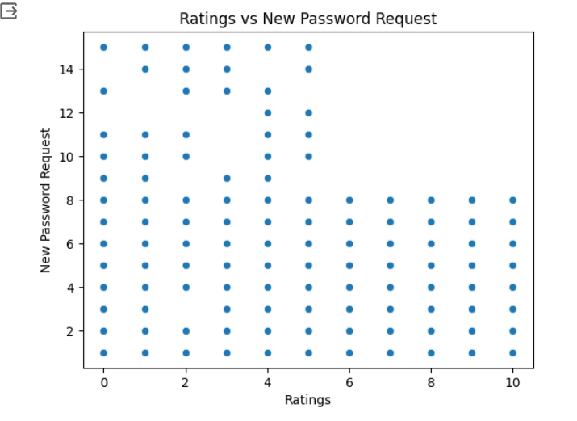

**Churn Analysis**

* **Distribution of Users by Installation Status**

